Project Design Phase
Problem – Solution Fit Template

Date | 19 July 2026
Team ID
Project Name | SHOPEZ: E-Commerce Application
Maximum Marks | 2 Marks

Problem – Solution Fit

Problem
Many customers find traditional shopping time-consuming and inconvenient because they must visit physical stores. Existing online shopping platforms can be expensive for small businesses, difficult to customize, and may not provide a simple, secure, and user-friendly shopping experience.
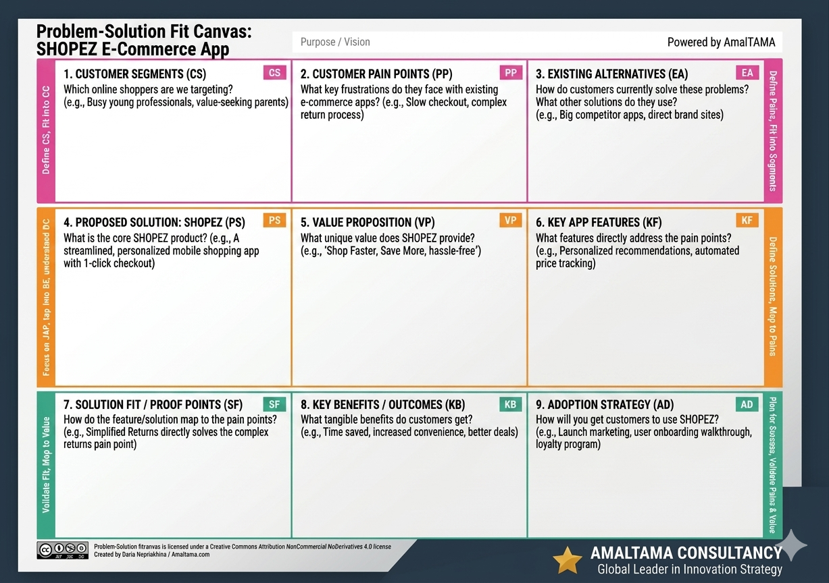

Target Customers
- Online Shoppers
- Small Business Owners
- Retail Store Owners
- Students and Working Professionals
- Customers who prefer online shopping

Customer Pain Points
- Time-consuming offline shopping.
- Difficulty in finding products quickly.
- Complicated registration and checkout process.
- Security concerns during online payments.
- Lack of efficient order tracking.
- Limited product management for store owners.

Proposed Solution
SHOPEZ is a MERN Stack–based e-commerce application that provides:
- Secure user registration and login using JWT authentication.
- Easy product browsing and category-based search.
- Shopping cart and wishlist management.
- Simple and secure order placement.
- Admin dashboard for product and order management.
- Responsive web interface for desktop and mobile browsers.

Value Proposition
- Saves customers' time through online shopping.
- Provides a secure and reliable shopping experience.
- Easy-to-use interface with fast product search.
- Helps administrators efficiently manage products and customer orders.
- Scalable architecture that supports future enhancements such as AI-based product recommendations and multiple payment gateways.
Expected Benefits
Stakeholder | Benefits
Customers | Quick, secure, and convenient online shopping experience.
Store Owners | Easy management of products, categories, and orders.
Administrators | Efficient monitoring of users, products, and transactions.
Business | Increased customer satisfaction, improved operational efficiency, and business growth.

Problem–Solution Fit Summary
Problem | SHOPEZ Solution
Customers spend time visiting physical stores. | Online shopping platform accessible anytime and anywhere.
Difficulty finding products. | Product search and category filtering.
Insecure authentication. | JWT authentication and bcrypt password encryption.
Complex order process. | Simple shopping cart and streamlined checkout process.
Manual product management. | Admin dashboard for efficient product and order management.
Future scalability issues. | MERN architecture supports scalability and future enhancements.

